P:\IVPA_Data\Springfield\Masters\IFVCC Logos\IFVCC Logo (BW).tif Illinois Family Violence Coordinating Council

Family Violence Coordinating Councils, at both the state and local/circuit levels, provide a forum to improve the institutional, professional and community response to family violence including domestic abuse, child abuse, abuse to people with disabilities and elder abuse. Councils provide professional education and prevention; coordinate interventions and services for victims and perpetrators; and contribute to both the improvement of the legal system and the administration of justice.

HOME PROJECTS PARTNERS ARCHIVE RESOURCES LCCs CONTACT

Initiated under the auspices of the Illinois Supreme Court in 1990, Illinois is one of the few states that has a systematically organized, statewide infrastructure that operates at both the state and local levels. Since the 1970's, a comprehensive, coordinated approach to preventing family violence has been promoted as the most efficient and effective way to penetrate systems and mobilize them for the greatest change. =

Events:

Trainings,

Activities,

Etc.

Annually, up to 15,000 professionals from across Illinois participate in trainings and council projects. These include family violence training and education of criminal justice and community professionals; development of criminal justice procedures, protocols, and services related to family violence; and the facilitation of coordinated community response to family violence in local areas. These Local Councils provide opportunities for communication between criminal justice professionals and community service providers as well as encourage the sharing of information and resources, thereby providing for development of a network of safety and assistance for family violence victims.

Chief and circuit judges convene and chair the 23 local councils in all 102 counties in Illinois which are composed of policy-level decision makers who represent agencies and services to help intervene and prevent family violence. Each council has approximately 100 individuals, including chief judges, circuit judges, probation officers, state’s attorneys, legal services, public defenders, law enforcements, circuit clerks, victims advocates, social services, public health professionals, clergy, educators, child protection services, public aid services, private attorneys and mediators.

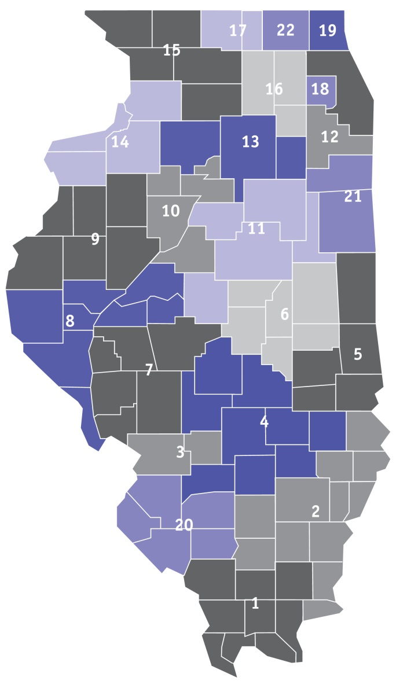Click on a circuit on the map to see local council information: